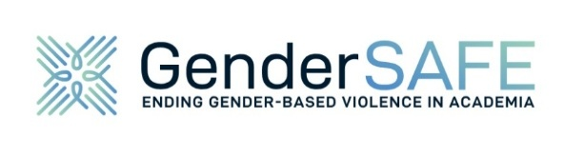
Press release
For immediate release
12 November 2025

GenderSAFE Launches Tool
to Help Institutions Address Gender-Based Violence

Strasbourg, France - On 26 November 2025, the EU-funded GenderSAFE project will officially launch its Institutional Self-Assessment Tool, a long-awaited resource designed to help higher education and research institutions assess, enhance, and monitor their response to gender-based violence.
This interactive tool guides institutions through a structured process based on seven key areas, known as Impact Drivers, and a six-stage maturity model (Starting Point | Project | Inception | Growth | Integration | Institutionalisation). It enables organisations to evaluate their current policies and practices, identify areas of strengths, gaps, and receive tailored recommendations for improvement. Designed for collaborative completion, it also helps to raise awareness internally and stimulate structured dialogue.
“Gender-based violence remains a deeply rooted issue across the European Research Area,” said Marcela Linková, Head of the Centre for Gender and Science, Institute of Sociology, Czech Academy of Sciences, and co-author of the methodology. “This tool is essential because it empowers institutions to move beyond symbolic commitments and identify concrete actions and practices to move them toward creating safer and more inclusive environments for all.”
Despite the existence of policies in many institutions, they lack efficiency and implementation often falls short. According to UniSAFE’s second policy brief (2022), institutions frequently fail to effectively prevent, protect, prosecute, provide services, and build partnerships. The GenderSAFE tool addresses this gap by offering a reflective and evidence-based approach to institutional transformation.
“We designed the tool to be actionable,” said Lut Mergaert, Research Director at Yellow Window and co-author of the methodology. “It not only helps institutions understand where they stand, it also fosters internal dialogue and learning. The feedback from pilot users confirmed its clarity and potential to drive meaningful change.”
Upon completion, institutions receive a detailed report and tailored recommendations. They are encouraged to repeat the assessment every 12–18 months to monitor progress. Future versions may include anonymised benchmarking features, allowing institutions to compare their progress across dimensions such as size, type, or country.
All data collected is handled with strict confidentiality. No institution’s data will be visible to another respondent or third party, and personal data is used solely for administrative coordination.
Join the launch webinar on 26 November 2025, 11:00 – 12:30 CET to learn more about how the tool can support institutional transformation. Register here.
The tool will be made available as open access on 26 November on the UniSAFE Toolkit and GenderSAFE website.
More information on the GenderSAFE website: https://gendersafe.eu
Media contact : communication@gendersafe.eu

